|  |  |  |
| --- | --- | --- |
| Name: ________________________________ | Homework Maths Challenge | Term 3 Week 3 |

|  |
| --- |
| Olympic Challenge - PART 3  There are 60 running races in the Olympic events. These are the different events for the running races.  Marathon, 10 000m, 5 000m, 1 500m, 800m, 400m, 200m, 100m and the relay.   * there is only ONE marathon * there are only TWO 10 000m races * there are only THREE 5 000m races * there are an EQUAL number of races for all the other events.  1. If there are 8 teams in each relay race and each team has 4 members, how many people are racing in the relays in total? (Show your working) 2. How many races for each event are there?  * marathon ________ * 10 000m ________ * 1 500m ________ * 800m ________ * 400m ________ * 200m ________ * 100m ________ * relay ________ |

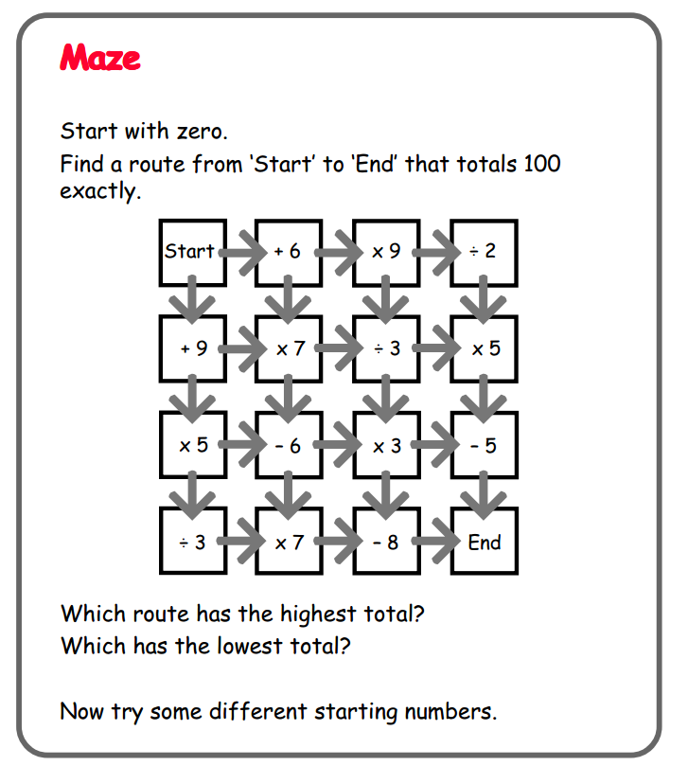

Create your own **Maze**.

|  |  |  |  |  |  |  |
| --- | --- | --- | --- | --- | --- | --- |
|  |  |  |  |  |  |  |
|  |  |  |  |  |  |  |
|  |  |  |  |  |  |  |
|  |  |  |  |  |  |  |
|  |  |  |  |  |  |  |
|  |  |  |  |  |  |  |
|  |  |  |  |  |  |  |