|  |  |  |
| --- | --- | --- |
| Name: ________________________________ | Homework Maths Challenge | Term 3 Week 2 |

|  |
| --- |
| Olympic Challenge - PART 2  Using the answers from last week’s Olympic Challenge complete the following question. |

**Races at the Olympics**

|  |  |
| --- | --- |
| Type of race | Number of races |
| Swimming races | 30 |
| Running races | 60 |
| Cycling races | 3 |
| Throwing races | 15 |
| Jumping races | 12 |

Mr A. Mazing is a super athlete who has entered all the Olympic events. Find out how many races in each event he has entered in total using the following information. He entered …

* One third of the cycling races. ______ cycling races
* 5/6 of the swimming events. ______ swimming races
* A fifth of the throwing events. ______ throwing races
* Three quarters of the jumping events. ______ jumping races
* 1/10 of the running events. ______ running races

Mr A. Mazing entered _________ races in total.

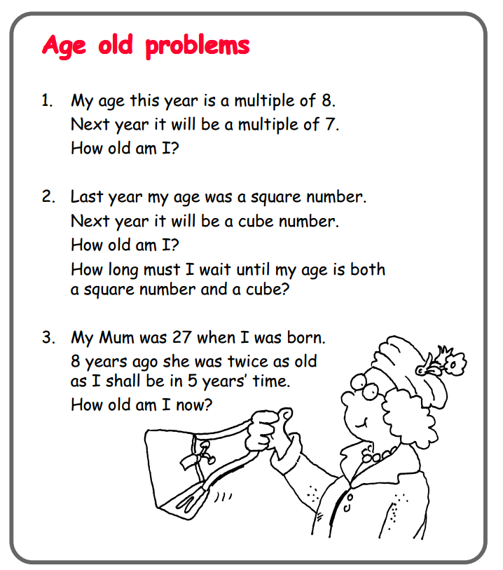

Create your own **Age Old Problem**.

____________________________________

____________________________________

____________________________________

____________________________________

____________________________________

____________________________________

____________________________________

____________________________________