|  |  |  |
| --- | --- | --- |
| Name: ________________________________ | Homework Maths Challenge | Term 3 Week 1 |

|  |  |  |  |
| --- | --- | --- | --- |
| Olympic Challenge - PART 1  Using the clues in the boxes below to complete the table **Races at the Olympics**. | | | |
| There are twice as many swimming races as there are throwing races. | One quarter of the races are swimming races. | In total there are 120 races. | 66% of the cycling competitors are boys. |
| There are more throwing races than jumping races. | Half of the races involve running. | The races which are not swimming, running, throwing or jumping are cycling races. | 10% of the races are jumping races. |

**Races at the Olympics**

|  |  |
| --- | --- |
| Type of race | Number of races |
| Swimming races |  |
| Running races |  |
| Cycling races |  |
| Throwing races |  |
| Jumping races |  |

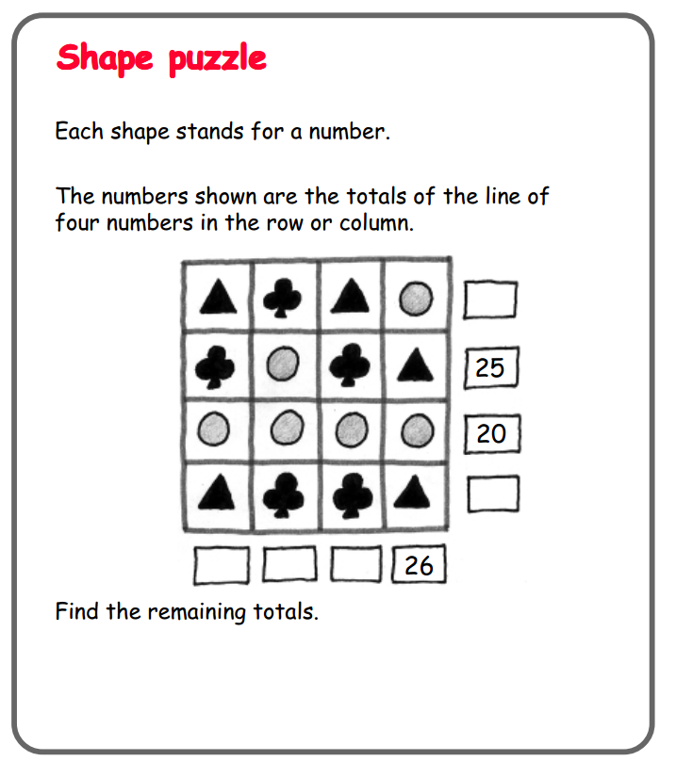

Create your own **Shape Puzzle** using the grid below.

|  |  |  |  |
| --- | --- | --- | --- |
|  |  |  |  |
|  |  |  |  |
|  |  |  |  |
|  |  |  |  |