Joke of the day: What gets wetter the more it dries? (Find the answer written somewhere on one of these pages!)

Student Spotlight **April Moore** from 6M. She said “I’m an expert at taking selfies and I recently reached 1000 selfies on my IPad!!!”

Contributions?

Have you got something you would like to contribute to our magazine? Maybe an artwork, a joke or a short story? If so, send your work to me (Imogen Smith 4/5LM) or give it to your teacher for her/him to pass on to me.

**Tongue twister**

Six slick sightseers click.

Alice Anderson

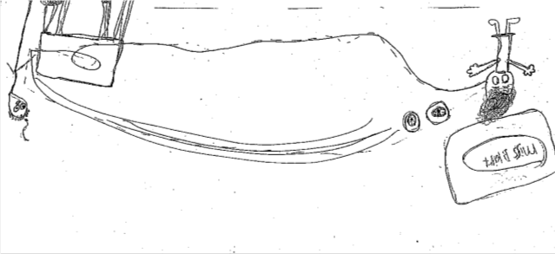Have you got a problem you would like help with? Have you got an annoying brother or sister? Well now you **can** have help. Send your problem to me (Imogen Smith 4/5LM) or give your problem to your teacher and your teacher will give it to me.

CRAZY FACT

Did you know that if you yelled for 8 years, 7 months and 6 days you would have enough energy to make a cup of coffee!

Selfie Competition!!!!

With each edition we are going to have a selfie competition, to enter your photo, find me (Imogen Smith 4/5LM) or give your photo to your teacher and your teacher will pass it on to me. Come with a selfie already printed and have your full name on the back. It is important that there is **NOTHING** violent or inappropriate. Also to enter this competition you **MUST** have your parent’s permission, as the winner’s photo will be shown in the next edition. Your photos must be in quickly because the winner will be announced next issue. The photo will be judged obviously on funniness. Also to enter the competition is free.

**The inside story of Mrs Hansell**

Mrs Hansell has been teaching at Hammondville Public School for 14.5 years.

Mrs Hansell has been a party coordinator at McDonalds, an administrator at QANTAS flight catering, counted traffic and drove a van with a pie on top before teaching.

She thinks the qualities of a good student are an intriguing mind, confidence to have a go and always reaching for the stars!!!!

For a period of her childhood, she attended Physical Culture, Netball and Nippers.

The first school she taught at was Villawood East Public School, with her best university friend Mrs Bruno.

As a child Mrs Hansell was inspired by her Mum to become an educator.

Her favourite band in the 80’s was Icehouse and she said “Iva Davies is the best!”

She went to Oyster Bay Public School.

Recipe from Mum’s kitchen

White chocolate and cranberry cookies (Gluten Free)

Ingredients:

125g butter

1/2 cup almond meal

1/2 cup caster sugar

1 egg

1/2 teaspoon vanilla essence

2/3 cup rice flour

1/2 cup corn flour

180g white chocolate (finely chopped)

½ cup dried cranberries

50g white chocolate (melted)

Method:

1. Preheat oven to moderate 1800C and lightly grease

and line 2 oven trays.

1. In a small bowl, using an electric mixer, beat butter,

almond meal, sugar and vanilla until creamy.

Add egg, beating well.

1. Stir in sifted flours, chopped chocolate and cranberries.

Roll spoonful’s of mix into balls. Place 5cm apart on tray.

1. Bake 15-20 mins until golden.
2. Drizzle with melted chocolate. YUM! YUM! YUM!

A towel