Hammondville Public School: Stage 2, Week 10 – Years 3 and Year 4 Remote Learning Timetable 13th - 17th September
 | Monday | Tuesday | Wednesday | Thursday | Friday
Morning | KLA English  Task 1 - Spelling and Grammar REVISION  Rule: When a word ends in e, you drop the e before adding -y.  For example: The word  ‘bubble’ becomes bubbly.  Rewrite these words to show your understanding of the rule.  - grease - laze  - craze - ease  - taste  Change these words to their base word.  - bubbly - rubbly  - snuggly - wheezy  - breezy  Please see the daily video for this task on Class Story or Google Classroom  Task 2 - Informative Writing  Choose any topic that interests you and research all about it. Some examples include: dinosaurs, cars, volcanoes, space etc.  Use different sources to gather your information - websites, books, magazines, newspaper articles etc. Fill in the note-taking graphic organiser with information you have researched. Write down the main idea of the topic, identify the informational language used throughout your source and list these under the key vocabulary, list the important information from the text, summarise what the information tells you and lastly write down the source of information.  Mindfulness Moment  Lead your mind to a natural place of rest with this calming mini meditation.  https://www.youtube.com/watch?v=ldFD-L-Csz0  Task 3 - Literacy activity  Follow the link to BTN to Answer the following questions Cinema Future :  https://www.abc.net.au/btn/classroom/cinema-future/13313584  1. What decade did we see our first movie theatres?  2. What did travelling theatre films look like?  3. Why were some of the first cinemas called nickelodeons?  4. When was television invented?  5. How did television affect cinema goers?  6. What impact has streaming services had on cinemas?  7. What did Warner Brothers decide to do with its movies made in 2021?  8. How were the Oscars awards different this year?  9. What do you think is the history of cinemas?  10. Name three things you learnt watching the BTN story. | KLA English  Task 1 - Spelling and Grammar REVISION  Compound sentences.  Two or more simple sentences joined together using a conjunction.  For example: This ball is too big and that ball is too flat.  We can see the word and is the conjunction that joins our two simple sentences.  Brainstorm and write a list of conjunctions.  Complete the compound sentence worksheet on paper or google classroom.  Task 2 - Informative Writing.  Watch the video on how to take notes https://www.youtube.com/watch?v=8trrhJBKEfo  Revisit the information source you used yesterday to research about your chosen topic again. Today, you’re going to be pulling apart the important information and filling out a fact file on your topic. Think back to your lesson on informational language – only pull out the key information and don’t copy it down word for word. Write at least 3 dot points in each box.  Mindfulness Moment  In just 5 minutes you can reset your day in a positive way.  https://www.youtube.com/watch?v=inpok4MKVLM&t=13s  Task 3 - Literacy activity  -Draw a basket at the bottom of the page in the middle  -Draw an apple tree to the left of the basket of apples.  - Draw fifteen apples on the tree.  -Colour all of the apples in the picture red.  -Draw a worm on one of the apple  -Draw yourself standing behind the apple basket. - Draw the sun in the top right corner of the picture.  -Draw three fluffy clouds in the sky.  - Draw a bird flying in front of one of the clouds.  -Colour the picture | KLA English  Task 1 - Spelling and Grammar REVISION  A verb is a doing word.  Think about some things  you have been doing in the  holidays such as riding,  walking, reading, building,  drawing, playing etc. Make  a list of verbs (at least 5  and no more than 15).  Have a go at writing some  sentences (Aim for 5 write  no more than 10),  describing what you have  been doing.  For Example: In the  holidays, I have been  going walking (verb) with  my  Task 2 - Informative Writing  Use your fact file on your topic from yesterday to write up an informative report. Make sure that you expand on your dot points that you wrote down and turn them into full sentences. Remember not to copy directly from the source that you used. You want to make sure that you are using your own words. Remember to include all the features of an informative report (title, subtitles, descriptive language, informational language, paragraphs, full sentences).  Mindfulness Moment  Find your focus with this mini meditation.  https://www.youtube.com/watch?v=IReEu2kI6oI  Task 3 - Literacy activity  Following instructions  -Draw a soccer goal  -Draw a green soccer field.  -Draw a soccer ball on the field.  -Draw you kicking the ball.  - Draw your best friend guarding the goal.  -Draw two orange cones on the field.  -At the top of the picture write, “Soccer Game Today”.  -Above the goal, write the score of the game.  Colour the picture | KLA English  Task 1 - Spelling and Grammar REVISION  Synonym - We often find ourselves using the same words when constructing our stories and sentences. Synonyms are words that have the same meaning as another word. Using a synonym can make our writing more exciting and enjoyable.  For example: said = exclaimed, demanded, yelled.  See if you can come up with 2 or 3 synonyms for the words in the list below.  - nice  - walk  - looked  - good  - bad  - pretty  Use 2 synonyms in a sentence.  Task 2 - Informative Writing  Today you’re going to publish your writing by creating an informative poster. Use your information from your report you created yesterday and create an eye-catching poster about your chosen topic. You can either draw the poster yourself, print pictures/information, or you can create it on Microsoft Word/PowerPoint. Make sure you include a big title, subheadings for each topic with informative paragraphs following, and pictures relating to your information.  Mindfulness Moment  Just tune in and feel the calm with this nature sounds meditation.  https://www.youtube.com/watch?v=Znyj6UBjz0A&t=95s  Task 3 - Literacy activity  This activity is listed in your daily activities where you can find the link and questions.  Follow the link to BTN and watch the entire BTN episode. Answer the questions. | Wellbeing Friday  Refer to the Wellbeing timetable provided
Break
Middle | KLA Maths  Task 1 Brain warm up  Complete the Monday column in the week 10 brain warm up worksheet.  Task 2 Subtraction  Complete the Subtraction worksheet.  Movement Break  Let’s move and stretch our bodies.  https://www.youtube.com/watch?v=LHjpGCj0PuM  Task 3 Prodigy  Spend 20 minutes battling on Prodigy. | KLA Maths  Task 1 Brain warm up  Complete the Tuesday column in the week 10 brain warm up worksheet.  Task 2 Mass  Please see the link below for this task or have a look on Class Story or Google Classroom.  https://www.youtube.com/watch?v=ivAD44nh0D0  Now complete the Mass worksheet.  Movement Break  It’s a Castle chase! Will you win the epic dragon battle?  https://www.youtube.com/watch?v=SFkQQOnX340&list=RDCMUC6mp1dGFmDN96FPWPIbsqeQ&index=15  Task 3 Mathletics  Spend 20 minutes on Mathletics and aim to complete at least 2 tasks. | KLA Maths  Task 1 Brain warm up  Complete the Wednesday column in the week 10 brain warm up worksheet.  Task Mass  Complete the Mass worksheet.  Movement Break  Get your body moving with the Cupid Shuffle!  https://www.youtube.com/watch?v=FgZobANrbfU  Task 3 Studyladder  Complete 2 tasks on Studyladder. Once logged in click on ‘all activities’ go to mathematics and select your grade and Mass. | KLA Maths  Task 1 Brain warm up  Complete the Thursday column in the week 10 brain warm up worksheet.  Task 2 Subtraction  Complete the Subtraction worksheet.  Movement Break  It’s another “What would you rather?’ workout. Make your choice and do the exercise.  https://www.youtube.com/watch?v=UKXR9wk0x_4&list=PLNYAo8Sgnckeaay7UGtkNZS6fQbQ5jFS7&index=8  Task 3 Prodigy  Spend 20minutes battling on Prodigy.
Break
Afternoon | KLA CAPA  Task 1  Today we are going to create a timeline of how television sets developed by watching the video, pausing and sketching the styles of tv’s that have come before the large, flat screens we commonly see today.  Use the worksheet or copy the labels given and create your timeline from left to right, sketching each style of tv from the video. Sketch an image of your favourite tv show in the last tv you drew from the 2000’s. Example: Teen Titans Go! Next, ask your parent/carer and grandparent about their favourite tv show as a child that you can sketch inside the 1980’s and 1960’s screens. Were they watching tv in black & white or colour? Did the tv need rabbit ears? See examples: 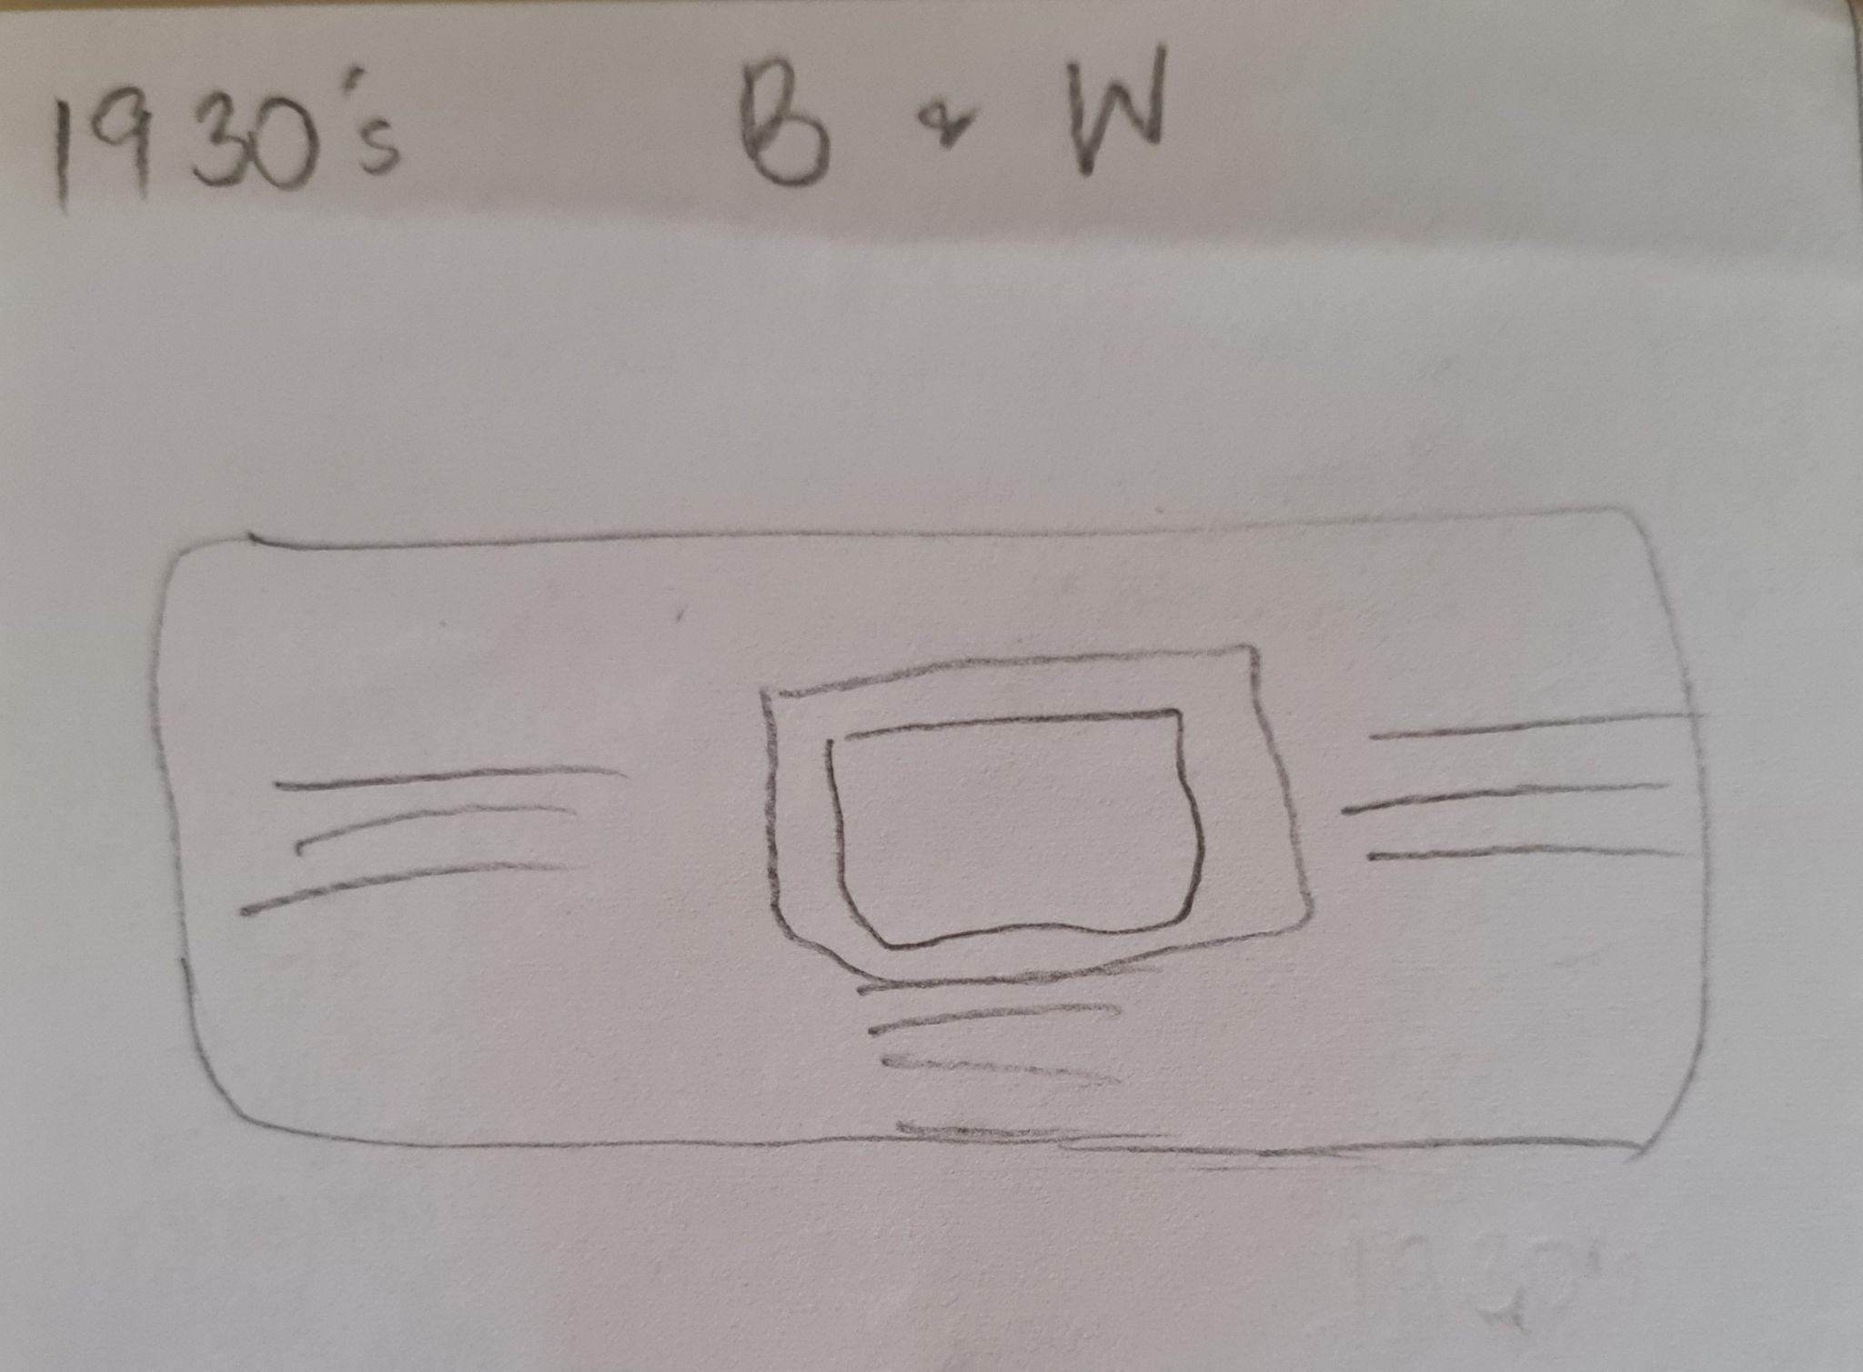  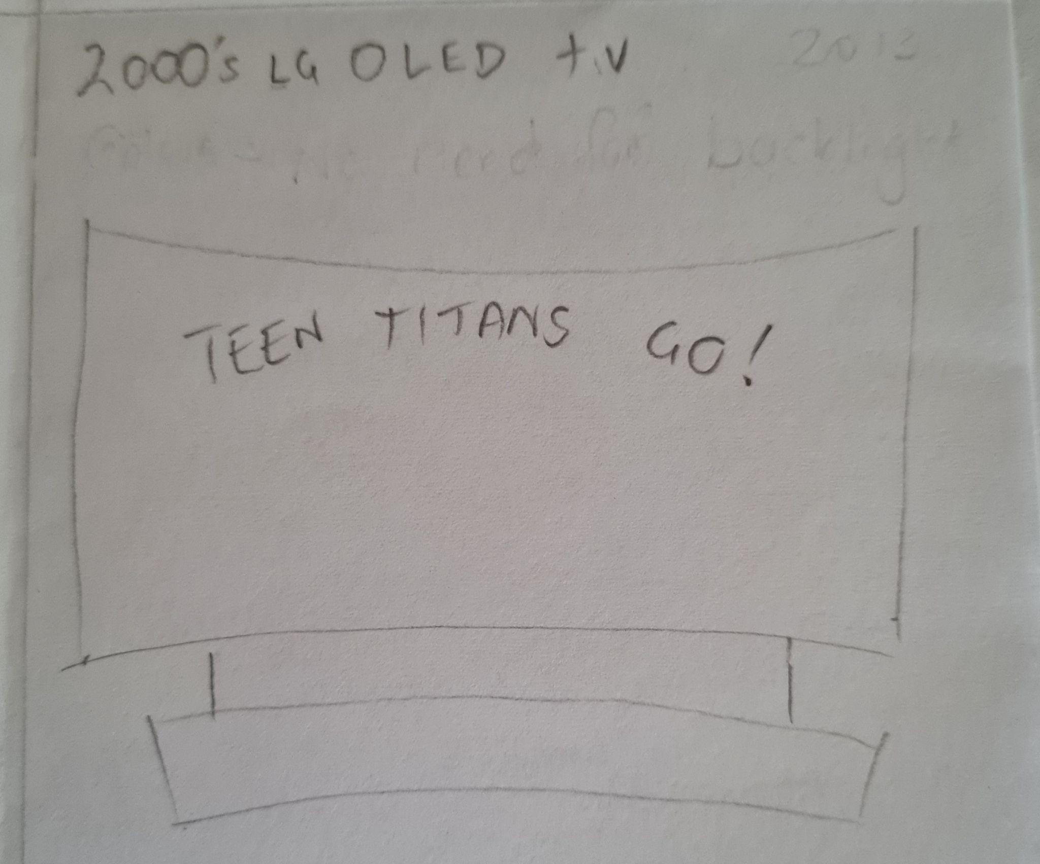  View the video here:  https://www.youtube.com/watch?v=tlPBTI_8BgA  KLA PDHPE  Task 1- Road safety rules  Visit the Road safety website for support in completing your worksheets titled ‘The Future is Here Now and Safe is as Safe Does’, for this week. This week is a revision of the road safety rules and reminds us of how to stay safe when out and about. If you get stuck completing your activities, revisit the websites from Weeks 8 and 9 to help you remember the rules. https://www.safety4kids.com.au/safety-zone/road-safety  The Power of Positivity  It’s really easy to think negatively, especially during times like these. Life can be tough, and it is easy to feel like you aren’t succeeding.  This week, we want you to focus on bringing some extra positivity into your life, through some positive self-talk.  Positive self-talk is one of the best things we can do to boost our happiness. When you’re in a positive frame of mind, we make better decisions, which can help us achieve our goals.  Choose four boxes from your Positive Self-Talk Journal to fill out today. | Library tasks  CATCH - UP  Go back through all the grids that Mrs Stanley has sent out and do anything you have not yet completed.  DO NOT redo any you have previously completed , give something new a go!  As always, keep your work for Mrs Stanley to see.  KLA PDHPE  Task 2 - Sports  In Term 3, Hammondville's PDHPE focus is on developing our Fundamental Movement Skills. Visit the Hammondville YouTube page at https://www.youtube.com/channel/UCFI8inXSYttI8PVkEcSuD7g to see what lessons and challenges Mr. Withers has set for you to participate in this week.​  The Power of Positivity  Let’s spread some positivity. Choose four boxes from your Positive Self-Talk Journal to fill out today. | KLA Geography (All of these tasks are found on Inquisitive) using the class code 1753: http://inq.co/class/AHD6J  Please see the daily video for this task on Class Story or Google Classroom  Task 1- What would it be like to live in another place?  -Watch the Video on Daisy and answer the questions about her daily life on a farm.  Task 2- Comparing the Similarities and Differences  -How is Daisy’s like similar and different to your own?  -Using google maps choose a different place to live and then complete question 12 on your new chosen place.  Task 3- Write a Journal Entry and reflections  -Students to either write about the new chosen place from task 2 or choose another place of interest to complete question 13.  -Question 14 is asking students to reflect on Sydney and the Kiwirrkurra community in Western Australia.  The Power of Positivity  Let’s spread some positivity. Choose four boxes from your Positive Self-Talk Journal to fill out today. | KLA Science  Please see the daily video for this task on Class Story or Google Classroom  Task 1 - Design Your Own Video Game Part 3  Now that you have brainstormed and created the elements needed for a video game, you are going to design a cover for the game. Don’t forget to include the title, the main characters and some setting/environmental factors from your game.  You are welcome to do this digitally on your computer, on a plain or coloured piece of paper or using the worksheet titled ‘Video Game Cover’.  The Power of Positivity  Let’s spread some positivity. Fill out the rest of the blank boxes in your Positive Self-Talk Journal today.

