Wellbeing Grid
Choose some activities from our Flexi Friday Grid to make a fun and mindful end to your week. We can’t wait to see what you enjoy. Submit your pictures to our school facebook page.
The great outdoors  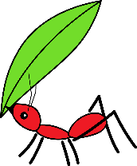  Find a way to explore in nature. It may be a bush walk, walk around your backyard looking for living things or a stroll around the block. | Movement  Go online and complete a “go noodle” guided dance or a “Just dance” routine. Always remember to be safe and warm up your body first.  GoNoodle | Guided Dance | Cooking  Find a new recipe and cook up a storm in the kitchen. Then the best part, eat it and enjoy. | Origami  Can you try the craft of Origami. You may make a paper aeroplane and see how far it files or get super creative and learn a more difficult origami pattern from online.
Draw, colour or sketch  Try drawing your favourite cartoon, a family member, a pattern or something you see in your garden. You may even find your favourite picture or pattern to colour in. | Lego  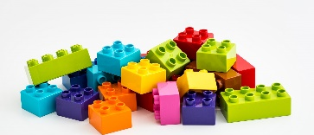  Use your lego, building blocks or other creative material in your house to build something that goes on water. | Board and Card Games  Enjoy playing a board or card game with your siblings or family. Remember to be a fair and respectful player. | Photography  Use a camera, phone or device and take some artistic photos of your favourite subjects.
Yoga  Visit the Cosmic Kids Yoga website and practise your Yoga skills.  Home - Cosmic Kids | Gratitude  Write down or tell someone 5 things you are thankful for this week. | Sensory  Spend time playing with a sensory toy. This may be playdough, kinetic sand, pop it, sandpit, slime or dirt/mud.  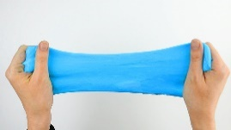 | Sidewalk drawing  Using chalk or a paintbrush with water draw some wonderful patterns and designs on your driveway or sidewalk.

